Time Series Project: USA Monetary Policy and Labor Market Outcomes
Jaydon Debus - STA 4853 - 2/25/2026

1. Introduction
The Federal Reserve, the central bank of the United States, has two important objectives: Promote maximum employment and to maintain stable prices. The primary tool for implementing monetary policy and achieving these objectives is through federal funds rate, which is the target interest rate at which commercial banks borrow and lend their excess reserves to each other. Changes in the federal funds rate have a ripple effect through the financial system and can influence other interest rates, ultimately affecting a wide range of economic activities. These include but are not limited to business investments, consumer spending, and labor market dynamics.

This project investigates the relationship between monetary policy actions and labor market outcomes. Specifically, it seeks to answer a key question: How do changes in the federal funds rate affect the U.S. unemployment rate? Determining the timing and magnitude of this effect is of great importance for many individuals. A couple of examples include policymakers needing to navigate the complex trade-offs between inflation and employment, businesses needing to make hiring and investment decisions, and for households planning their financial futures. The transmission of monetary policy to the labor market is not instantaneous, it is characterized by significant and variable lags. These delays require careful analysis to uncover the true impact of policy decisions.

To measure this lagged relationship, this project employs a distributed lag model. This approach is particularly well-suited for not only estimating the direction and magnitude of the effect, but also for mapping out the impact of a change in the federal funds rate unfolds on the unemployment rate over subsequent months. The analysis is based on publicly available time series data from the Federal Reserve Bank of St. Louis's FRED database, including the effective federal funds rate, the civilian unemployment rate, and the Consumer Price Index (CPI) as a control for inflation.

This report is structured as follows: Section 2 details the methodology, including data collection, preprocessing, and the specification of the distributed lag model. Section 3 presents the empirical results of the analysis, including the estimated model and its interpretation. Finally, Section 4 concludes with a discussion of the policy and business implications of the findings, acknowledges the limitations of the study, and suggests opportunities for future research.

2. Methodology
This study employs a quantitative approach to examine the dynamic relationship between U.S. monetary policy and labor market outcomes. The methodology encompasses data collection from a reputable source, preprocessing, stationarity testing of the time series, and the specification and estimation of a distributed lag model.

2.1 Data and Preprocessing
The analysis utilizes monthly time series data obtained from the Federal Reserve Economic Data (FRED) database, provided by the Federal Reserve Bank of St. Louis. The data was imported and analyzed using R Studio using the “quantmod” package. The selected variables span from January 2000 to January 2026, providing 26 years of monthly observations. This time frame was chosen because it encompasses recent, important, worldwide economic events like the 2008 Financial Crisis and 2020 global COVID-19 outbreak. The three series used are summarized in the table below.

Variable | FRED Series ID | Description | Role in Model
Unemployment Rate | UNRATE | Civilian unemployment rate (%) | Dependent variable
Federal Funds Rate | FEDFUNDS | Effective federal funds rate (%) | Key explanatory variable
Consumer Price Index | CPIAUCSL | CPI for All Urban Consumers | Control variable (inflation)

Initial exploratory data analysis involved plotting the three time series to visually inspect trends, seasonality, and structural breaks. As shown in Figure 1, the CPI exhibits a persistent upward trend, the federal funds rate displays clear cyclical behavior tied to the business cycle, and the unemployment rate shows pronounced spikes during recessions, most notably during the 2008 financial crisis and the COVID-19 pandemic in 2020.
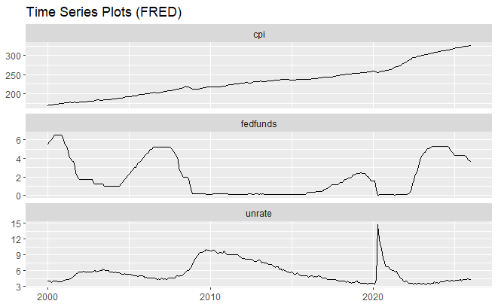

A seasonal plot of the unemployment rate (Figure 2) revealed no strong or consistent seasonal pattern, suggesting that seasonal adjustment is not a primary concern for this analysis.

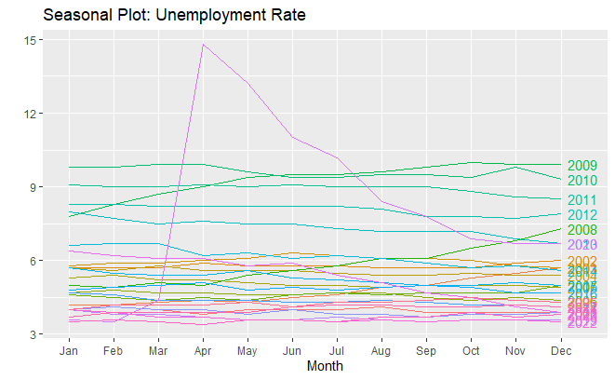

To prepare the data for modeling, the inflation rate (infl) was constructed as the monthly log-difference of the CPI, multiplied by 100 to express it as a percentage:

$$infl= 100 × ln(CPI) - ln(CPI\{t-1\})$$

2.2 Stationarity Analysis
Given the patterns commonly observed in economic time series, an assessment of stationarity is essential prior to modeling. Non-stationary variables can create spurious regressions, producing misleading coefficient estimates and invalid inference. Stationarity was assessed using both visual inspection of Autocorrelation Function (ACF) and Partial Autocorrelation Function (PACF) plots, and formal statistical testing via the Augmented Dickey-Fuller (ADF) test.

The ACF/PACF plots in Figure 3 illustrate the behavior of the unemployment rate at both the level and first-differenced form. The level series shows a very slow decay in the ACF, a giveaway of a non-stationary, variable. After differencing, the ACF drops to near zero for all lags beyond lag 0, confirming stationarity.

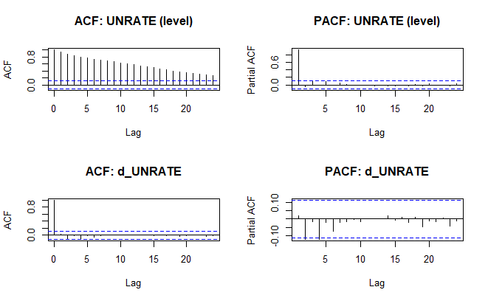
The ADF test results, summarized in the table below, confirms the visual evidence.
Variable | ADF Statistic | p-value | Conclusion
UNRATE (level) | -2.488 | 0.371 | Non-stationary
d_UNRATE (differenced) | -7.859 | 0.010 | Stationary
FEDFUNDS (level) | -3.648 | 0.029 | Stationary
d_FEDFUNDS (differenced) | -3.790 | 0.020 | Stationary
infl (log-diff CPI) | -5.206 | 0.010 | Stationary

The unemployment rate in levels fails to reject the null hypothesis of a unit root (p = 0.371), while its first difference is clearly stationary (p = 0.01). The federal funds rate is borderline stationary in levels (p = 0.029), but to ensure consistency and robustness, its first difference was also used in the model. The inflation rate was stationary in its constructed form. The final model is estimated using the first differences of both the unemployment rate (d_unrate) and the federal funds rate (d_fedfunds), along with the level of the inflation rate (infl).

2.3 Distributed Lag Model Specification
To capture the delayed impact of monetary policy on the labor market, a finite distributed lag (FDL) model was specified. This model regresses the current change in the unemployment rate on contemporaneous and lagged values of the change in the federal funds rate, along with a contemporaneous inflation control. The model is expressed as:
$${ΔUNRATE}_{t}​=α+\sum_{k=0}^{12}{​{βk​ΔFEDFUNDS}_{t-k}​+{γInflation}_{t}​+u_{t}}​$$
${ΔUNRATE}_{t}​$ represents the month-to-month change in the unemployment rate, measured in percentage points. By modeling changes rather than levels, the analysis focuses on short-run adjustments in labor market conditions rather than long-run trends.
${βk​ΔFEDFUNDS}_{t-k}$ represents the effect of a change in the federal funds rate from k months prior on the current month's change in the unemployment rate.
${γInflation}_{t}$ represents the monthly inflation rate, calculated as the log-difference of the Consumer Price Index (CPI). The coefficient γ controls for concurrent price-level changes that may independently influence labor market dynamics.
The error term $u_{t}$ captures unobserved factors that cause changes in unemployment that are not explicitly included in the model, such as fiscal policy shocks, global economic developments, or structural labor market changes.

The maximum lag length (K) was selected by evaluating the Akaike Information Criterion (AIC) and the Bayesian Information Criterion (BIC) across models with K ranging from 0 to 18. As shown in Figure 4, the BIC is minimized at K = 2, while the AIC continues to decline until approximately K = 9 before flattening. Given that economic theory suggests monetary policy effects can take several quarters to fully materialize, a maximum lag of K = 12 was chosen for the final model to ensure that the full scope of the lagged response is captured.
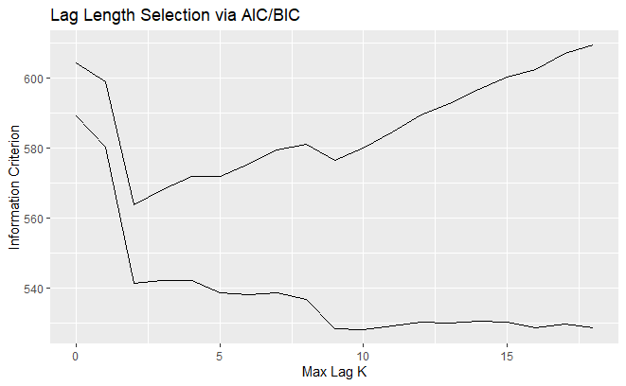

2.4 Estimation and Diagnostics
The distributed lag model was estimated using Ordinary Least Squares (OLS). Following estimation, a series of diagnostic tests were conducted on the model residuals to check for violations of classical assumptions. The Durbin-Watson and Breusch-Godfrey tests were used to detect serial correlation, and the Breusch-Pagan test was applied to test for heteroskedasticity. Newey-West heteroskedasticity and autocorrelation consistent (HAC) standard errors were computed to ensure valid statistical inference.

3. Results
The estimation of the distributed lag model yields several key findings regarding the dynamic impact of federal funds rate changes on the U.S. unemployment rate. The overall model was statistically significant, with an F-statistic of 7.936 on 14 and 284 degrees of freedom, corresponding to a p-value of 3.16 × 10⁻¹⁴. The model explains approximately 24.6% of the variance in the monthly change in the unemployment rate (Adjusted R² = 0.2458).

3.1 Lagged Effects of Monetary Policy
The core of the analysis lies in the interpretation of the individual lag coefficients (β), which track the response of the unemployment rate to a monetary policy shock over time. The estimated coefficients from the model with a maximum lag of 12 months are presented in the table below, with standard errors corrected for heteroskedasticity and autocorrelation using the Newey-West procedure.
Lag (Months) | Coefficient (β) | Newey-West Std. Error | t-statistic | p-value
0 | -0.026 | 0.244 | -0.105 | 0.917
1 | -2.300 | 1.529 | -1.504 | 0.134
2 | 1.940 | 1.325 | 1.464 | 0.144
3 | -0.267 | 0.302 | -0.887 | 0.376
4 | 0.431 | 0.431 | 0.999 | 0.319
5 | -0.544 | 0.518 | -1.050 | 0.295
6 | 0.042 | 0.227 | 0.186 | 0.853
7 | 0.572 | 0.337 | 1.699 | 0.090
8 | -1.001 | 0.629 | -1.592 | 0.112
9 | 1.009 | 0.665 | 1.517 | 0.130
10 | -0.214 | 0.211 | -1.014 | 0.312
11 | -0.113 | 0.182 | -0.619 | 0.536
12 | -0.075 | 0.184 | -0.405 | 0.686
infl | -0.291 | 0.189 | -1.542 | 0.124
The distributed lag coefficient plot in Figure 5 provides a visual representation of the estimated impulse response function.
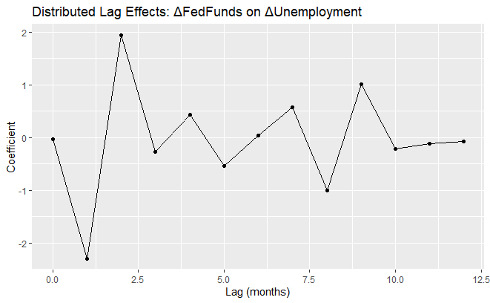

The results reveal a complex and alternating pattern of lagged effects. After correcting for heteroskedasticity, only the coefficient at lag 7 is marginally significant at the 10% level (p = 0.090), suggesting that a one-percentage-point increase in the federal funds rate is associated with a 0.572 percentage-point increase in the change in unemployment approximately seven months later. The large negative coefficient at lag 1 (β₁ = −2.300) and the corresponding positive coefficient at lag 2 (β₂ = 1.940) are noteworthy, though they do not achieve statistical significance under the more conservative Newey-West standard errors. This oscillating pattern at early lags may reflect short-run market adjustments and noise rather than a stable structural relationship.
The cumulative effect of a one-percentage-point increase in the federal funds rate, summed across all 13 lag coefficients, is −0.545 percentage points in the change in unemployment. While this negative cumulative effect runs counter to the conventional expectation that rate hikes raise unemployment, it is not statistically significant and should be interpreted with caution.

3.2 Model Diagnostics
Diagnostic tests on the model residuals were conducted to assess the validity of the model assumptions. The results are summarized in the table below.
Diagnostic Test | Test Statistic | p-value | Conclusion
Durbin-Watson | DW = 1.884 | 0.147 | No significant first-order autocorrelation
Breusch-Godfrey (order 12) | LM = 19.487 | 0.077 | Weak evidence of higher-order serial correlation
Breusch-Pagan | BP = 74.828 | < 0.001 | Significant heteroskedasticity detected
The Durbin-Watson statistic of 1.884 (p = 0.147) provides no significant evidence of first-order serial correlation. The Breusch-Godfrey test for serial correlation up to order 12 yields a p-value of 0.077, indicating some weak evidence of remaining serial correlation but not enough to reject the null at the 5% significance level. The ACF and PACF plots of the residuals in Figure 6 confirm that most autocorrelation has been accounted for, with only a few lags marginally exceeding the confidence bounds. Finally, The Breusch-Pagan test is highly significant (p < 0.001), confirming the presence of heteroskedasticity. This finding approves the use of Newey-West robust standard errors, which account for both heteroskedasticity and autocorrelation in the error term.

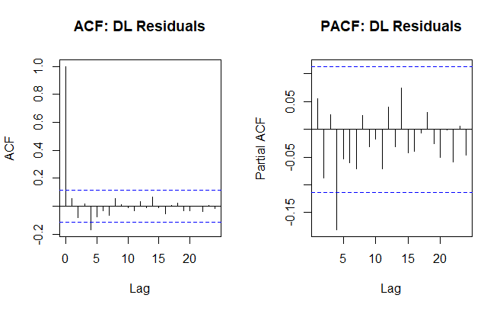

4. Conclusion
This project set out to investigate the dynamic impact of changes in the federal funds rate on the U.S. unemployment rate using a distributed lag model for the period from January 2000 to January 2026. The analysis revealed a complex relationship between monetary policy and labor market outcomes. While the overall model was statistically significant, the individual lagged effects of monetary policy on unemployment were largely statistically insignificant after correcting for heteroskedasticity with Newey-West standard errors. The results do not provide clear evidence of a simple, predictable delayed relationship where rate hikes systematically raise unemployment within a 12-month horizon.

4.1 Policy and Business Implications
The findings carry important implications for both policymakers and business leaders. For policymaker’s, the lack of a strong and statistically significant signal from this model underlines the challenge of navigating the trade-off between inflation and unemployment. The monetary policy transmission mechanism to the labor market appears to be more complex than a simple lagged effect, potentially involving reactions with other macroeconomic variables. This underscores the difficulty of "fine-tuning" the economy and suggests that policy decisions must be made with a degree of humility about their precise impact on the labor market.
For businesses, the uncertainty in the relationship between interest rates and unemployment complicates strategic planning. Relying on the simple idea that interest rate hikes will curb economic activity and increase unemployment after a specific delay may be misleading. The oscillating pattern of the estimated coefficients suggests that short-term effects could even run counter to long-term expectations.

4.2 Limitations
Several important limitations of this analysis must be acknowledged. First, the distributed lag model does not account for potential endogeneity. The Federal Reserve sets interest rates in response to economic conditions, including the unemployment rate itself. This creates a two-way causality that a single-equation model cannot resolve. Second, the model may suffer from omitted variable bias, as numerous factors such as fiscal policy, global economic conditions, and shifts in labor force participation also influence unemployment. These were excluded for simplicity’s sake. Third, the presence of strong heteroskedasticity and the heavy-tailed residuals suggest that the COVID-19 shock in 2020 is a significant outlier that may distort the estimated relationships. Finally, the choice of a 12-month lag length, while economically motivated, differed from the simpler specification suggested by the BIC criterion.

4.3 Future Research
Several opportunities for future research could build upon this work. Employing a Vector Autoregression (VAR) model would allow for simultaneous modeling of the feedback between the federal funds rate and unemployment, which would help address the endogeneity concern.. Additionally, excluding or controlling for the COVID-19 period as a structural break, or extending the sample to include earlier decades, could improve the stability and interpretability of the estimated coefficients.

References
Federal Reserve. (2021, July 29). Monetary Policy: What Are Its Goals? How Does It Work?
Federal Reserve Board. (n.d. ). The Fed Explained — Monetary Policy.
Cagan, P. (1972 ). The lag in monetary policy as implied by the time pattern of monetary effects on interest rates. Journal of Money, Credit and Banking, 4(1), 1–16.
Federal Reserve Bank of St. Louis. (n.d. ). Federal Reserve Economic Data (FRED).

